The core idea: an image is just numbers in a grid.
Made a fake grayscale image
That's literally the entire definition of a grayscale image. No color, no extra info — just "how bright is this dot."
cmap='gray' is the rule that turns numbers into colors
When you call: plt.imshow(img, cmap='gray')
you're telling matplotlib: "use a scale that goes from black to white, and place each number on that scale based on how big it is."

The rule, specifically:
- 0 → pure black
- 255 (or 1.0 if using floats) → pure white
- anything in between → a proportional shade of gray

it’s a 2d pixel(5,5) & 3 is the array containing RGB
color[:, :, 0] = 100 //rows,cols, channel (R=0, G=1, B=2)

example1:
color = np.zeros((5,5,3), dtype=np.uint8) # tells numpy/matplotlib "these>
color[:,:,0] = 100 # what does this do? guess before running
plt.imshow(color, cmap='gray')
plt.show()

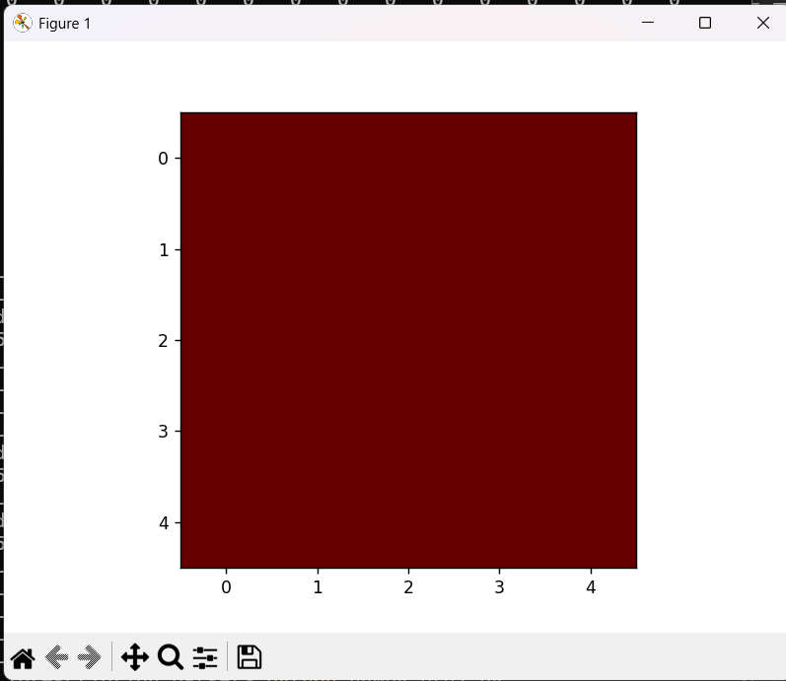

example2:
color = np.zeros((5,5,3), dtype=np.uint8) # tells numpy/matplotlib "these>
color[2,1,1] = 150 # what does this do? guess before running
plt.imshow(color, cmap='gray')
plt.show()
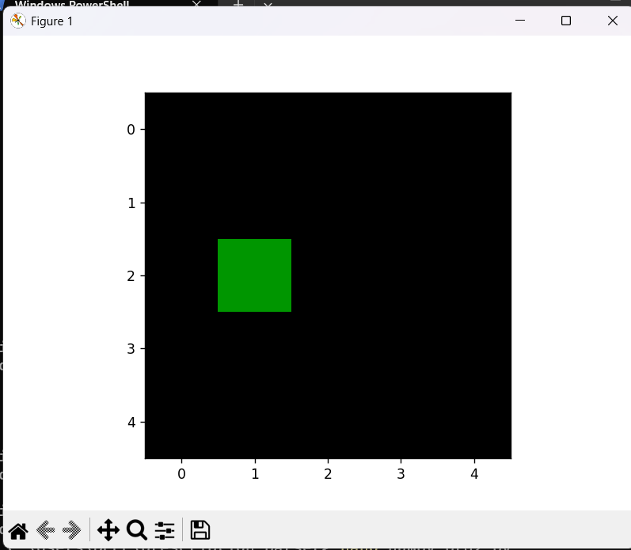
That pixel started as [0, 0, 0] (black, from np.zeros). After this line, it becomes [0, 150, 0] — Red=0, Green=150, Blue=0. Zero red, zero blue, moderate green → that's exactly the green square you see, sitting at row 2, column 1, while every other pixel is untouched and stays [0,0,0] (black).

